**Presentation Notes:**

1. What are the four functions of a computer program listed on the lesson slide?
   1. It controls the hardware of a computer system.
   2. It decides how input devices impact output devices.
   3. Changing the program affects the function of the hardware of the computer.
   4. Can control more computer systems than you would think.
2. Provide an example of a computer input that is not listed on the lesson slide.

An example of a computer input not displayed on the lesson slide would be a microphone

1. Provide an example of a computer output that is not listed on the lesson slide.

A printer is an unlisted output device.

1. Provide another example of how a computer input affects a computer output that is not listed on the lesson slide.

Clicking the print button can cause a paper to be printed with what you have worked on displayed on it.

1. Provide an example of how changing the program changes how computer inputs affect computer outputs that is not listed on the lesson slide.

A PDF to JPEG converter gives a different output than a virus scanner as you see different things from the monitor

1. What are some examples of devices that are not traditional computers but that make use of computer programs?
   1. Digital Billboards
   2. Samsung Smart Fridge
   3. Industrial Robots
   4. Cars
   5. Internet Bots
   6. Smart Phones
2. Provide another example of a device that makes use of a computer program that is not listed on the lesson slide.

Digital Billboards

1. What is another term for a computer program?

Computer Software

1. What are some ways that computer software is different from computer hardware?

Software is flexible and easily changed hardware is physical and is hard to change.

1. How are computer programs written?

They are written in a collection of simple logical statements that causes a complex logical thing to happen. They can be very large and take a lot of code to do complex things.

1. Why are computer programs composed of many lines of computer code?

Because the computer cannot store differently the ability to perform tasks built in with hardware and instead uses simple commands to do harder things because it is easier to store simpler commands and they are closer to assembley.

1. List some examples of different computer languages.
   1. Java
   2. C / C+
   3. COBOL
   4. SQL
2. List some of the benefits of the Python computer language.
   1. Professional language with large user base
   2. Good for prototyping small programs
   3. Good beginner language
   4. Language of choice for 1st year university courses
3. Once you finish this course, how could you answer someone who asks you "Do you know how to program in Java?"

Yes, because other than small differences python and Java are fairly similar.

1. Could you use Microsoft Word to write a computer program? Explain.

You could use Microsoft word to write a computer program because any word processor works, it just wouldn’t correct your programming errors

1. What does IDE stand for?

Integrated Development Environment

1. What are some features of an Integrated Development Environment?
   1. Colour coding of keywords
   2. Indentation and completion control
   3. Error checking
   4. Runtime support and debugging
   5. Provides extra supports and tools for creating and maintaining programs
2. What are some factors to consider when choosing an Integrated Development Environment?
   1. How well does it support the language you use?
   2. Is it on the internet or does it require an install
3. What is the name of the IDE that we will be using to create our Python programs?

Repl.it

1. What version of Python will we be using?

3.7.3

1. Draw a sketch of the Repl interface showing the three work areas (panels)
   1. Label each panel
   2. Summarize the function of each panel

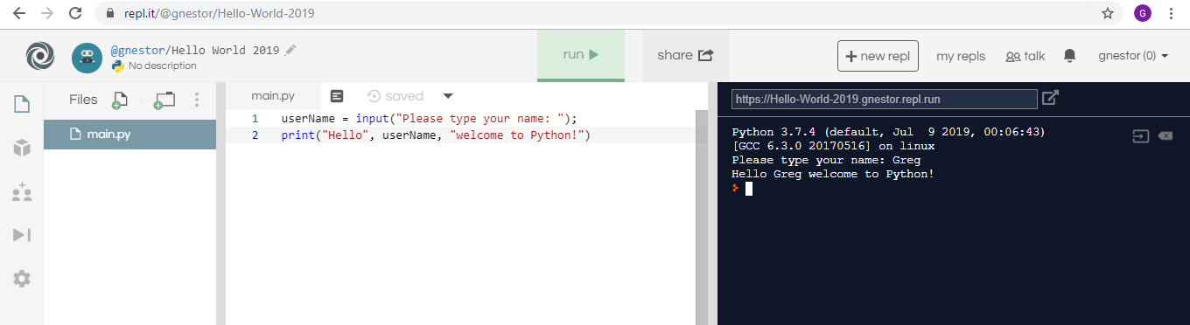

^ ^ ^

File Chooser Program Editor

**Student Questions:**

1. Create an account for yourself at www.repl.it
   1. Review the "Terms of Service" to verify that you can legally use this service.
   2. Follow the previous discussed guidelines regarding use of personal information
2. List the part of the "Terms of Service" that verifies that you can legally use this service.

**The part that verifies this is called General Use of the Service-Permissions and Restrictions.**

1. Explain some of the rights that you give away to Repl.it regarding content you create using their service?

You can’t use repl.it to make a site and then sell ads on that site. You can’t use it to hack other websites. You can’t take repl.it and customize it. You can’t use a Repl.it service on a site not owned by the company that owns it.

1. Create a new Python repl and call it "Hello World".
2. Copy and paste the following program into the program panel (white area)

userName = input("Please type your name: ");

print("Hello", userName, "welcome to Python!")

1. Run the program to see what it does. (If necessary, fix the quotation marks so it runs properly.)

A: Explain how the program works.

B: Explain how you fixed the program (if necessary)

A: The program takes your input and then displays it between the string “Hello” and the string “welcome to Python”

B: The program worked for me.

1. Try using the console pane (black area) to perform some simple calculations and run some one-line programs.
   1. Summarize some of your calculations.

My calculations determined that Python has built in BEDMAS and consisted of multiplication and addition.

1. Try using the file management pane to add some files and folders to your repl.
   1. Summarize some of your additions.

I added a new file to the project and opened it, it was like the first and was positioned under the first in the file manager.